SOFTWARE CHANGE IMPLEMENTATION REPORT

CR004: Student Input Field Validation for Add and Edit Operations
Field | Details
Change Request ID | CR004
Change Request Title | Student Input Field Validation for Add and Edit Operations
Student Name | Susmitha Vimalarajan
Student ID | JFICT24_30
Implementation Status | Completed
Date | 08 October 2026

Change Request Summary

Business Requirement
Administrators currently can enter student information without sufficient validation when adding or editing students. For example, a phone number containing only a few digits may be accepted, and names with fewer than three characters or weak passwords may also be entered. As incorrect or insecure information can affect data quality and account security, the system should validate all student input fields before accepting the data. The system should ensure that student names, registration number, email address, phone number, and password follow the required validation rules

Existing Behaviour
- StudentFormModal.jsx performs only basic required-field checking.
- A phone number with fewer than 10 digits may be accepted.
- A phone number with more than 10 digits may be entered.
- Non-numeric characters may be entered into the phone number field.
- First name and last name do not have a minimum 3-character requirement.
- Invalid characters may be entered into name fields.
- Email format is not sufficiently validated.
- Registration number does not have comprehensive input validation.
- New student passwords do not enforce a strong password policy.
- Backend validation does not comprehensively validate all student input fields.
- Invalid data may potentially be submitted directly to the backend without passing clientside validation.

Requested Change
Add comprehensive validation to the student Add and Edit operations.
The implementation must:
- Validate all required student fields before submission.
- Require a valid registration number.
- Require first name and last name to contain at least 3 characters.
- Allow valid alphabetic characters in first name and last name.
- Reject invalid numbers or inappropriate special characters in names.
- Validate the email address using a valid email format.
- Require the phone number to contain exactly 10 digits.
- Allow only numeric characters in the phone number.
- Reject phone numbers containing fewer than 10 digits.
- Reject phone numbers containing more than 10 digits.
- Require a password when creating a new student.
- Require the password to contain at least 8 characters.
- Require at least one uppercase letter in the password. • Require at least one lowercase letter in the password.
- Require at least one number in the password.
- Require at least one special character in the password.
- Display clear validation error messages to administrators.
- Prevent invalid data from being submitted from the frontend.
- Apply server-side validation to prevent client-side validation bypass.
- Preserve existing Add, Edit, and Delete functionality.
- Maintain existing administrator authentication and authorization.
- Continue securely hashing passwords before storing them in the database.

Implementation

Implementation Summary
CR-004 was implemented to improve the validation of student information during the Add Student and Edit Student operations in the Student Management System.
The main purpose of this change was to prevent administrators from submitting incomplete, invalid, or insecure student information. Both client-side validation and server-side validation were implemented to ensure that invalid data is rejected before it can be stored in the database.
The implemented validation covers the following student fields:
- Registration Number
- First Name
- Last Name
- Email Address
- Phone Number
- Password
The validation rules ensure that student names contain valid characters and have a minimum length of three characters, email addresses follow a valid format, phone numbers contain exactly ten numeric digits, and new student passwords satisfy the required password strength policy.
Server-side validation was also added to prevent users from bypassing frontend validation by directly sending invalid requests to the API.
Existing student Add, Edit, Delete, authentication, authorization, database operations, and password hashing mechanisms were preserved.

Affected Files
File | Change | Purpose
frontend/src/components/StudentFormModal.jsx | Modified | Implemented client-side validation for student Add and Edit operations and displayed validation error messages.
backend/controllers/studentController.js | Modified | Implemented server-side validation for registration number, names, email, phone number, and password.
Existing student model/API files | No change | Existing database operations and API endpoints were preserved.
Additional files: None

Technical Changes

Registration Number Validation
The registration number is validated before the Add or Edit operation.
The validation ensures that:
- The registration number is not empty.
- The registration number follows the accepted format.
- Invalid registration numbers are rejected before database operations.

Name Validation
Validation was added for both first name and last name.
The validation ensures that:
- The field is required.
- The name contains at least 3 characters.
- Valid alphabetic characters are accepted.
- Numbers are rejected.
- Inappropriate special characters are rejected.

Email Validation
Email validation was implemented to ensure that the entered email follows a valid email format.
Invalid email addresses are rejected before submission.

Phone Number Validation
Phone validation was implemented to ensure that:
- The phone number is required.
- Only numeric characters are accepted.
- Exactly 10 digits are required.
- Numbers containing fewer than 10 digits are rejected.
- Numbers containing more than 10 digits are rejected.

Strong Password Validation
Strong password validation is applied when creating a new student.
The password must contain:
- At least 8 characters.
- At least one uppercase letter.
- At least one lowercase letter.
- At least one number.
- At least one special character.
The existing password hashing mechanism was preserved, and passwords continue to be securely hashed before being stored.

Implementation Logic
- Administrator opens the Add or Edit Student form.
- Student information is entered into the form.
- Client-side validation checks the entered information.
- If invalid information is entered, appropriate validation errors are displayed.
- Form submission is prevented when validation fails.
- Valid information is submitted to the existing student API endpoint.
- The backend performs server-side validation again.
- If backend validation fails, the API returns a validation error response.
- If validation succeeds, the existing Add or Edit operation continues.
- During student creation, the password is securely hashed using the existing password hashing mechanism.
- Valid student information is saved successfully.
- Existing Edit and Delete functionality continues to operate using the existing student identity and authorization mechanisms.

Error and Data Handling
Clear validation error messages are displayed when invalid information is entered.
Examples of validation messages include:
- Registration number is required.
- First name must be at least 3 characters.
- First name contains invalid characters.
- Last name must be at least 3 characters.
- Last name contains invalid characters.
- Please enter a valid email address.
- Phone number must contain exactly 10 digits.
- Phone number must contain numbers only.
- Password must be at least 8 characters.
- Password must contain at least one uppercase letter.
- Password must contain at least one lowercase letter.
- Password must contain at least one number.
- Password must contain at least one special character.
Invalid frontend submissions are prevented from reaching the API.
Server-side validation provides an additional protection layer against direct API requests containing invalid information.

Testing & Verification

Testing Approach
The implementation was verified through manual frontend and backend testing.
Testing Types:
- Functional testing
- Positive testing
- Negative testing
- Validation testing
- UI testing
- Server-side validation testing
- Regression testing
- CRUD verification
- API testing
- Security validation

Environment
Environment: Development
Browser: Chrome
Test Role: Administrator
Backend Testing Tool: Postman

Test Cases
ID | Test Case | Expected Result | Actual Result | Status
TC01 | Submit form with empty required fields | Validation errors are displayed and submission is prevented | Required field errors displayed | Pass
TC02 | Enter first name with fewer than 3 characters | First name is rejected | First name rejected | Pass
TC03 | Enter last name with fewer than 3 characters | Last name is rejected | Last name rejected | Pass
TC04 | Enter numbers in first/last name | Invalid name is rejected | Invalid name rejected | Pass
TC05 | Enter inappropriate special characters in name | Invalid name is rejected | Invalid name rejected | Pass
TC06 | Enter invalid email address | Email is rejected | Invalid email rejected | Pass
TC07 | Enter phone number with fewer than 10 digits | Phone number is rejected | Phone number rejected | Pass
TC08 | Enter phone number with more than 10 digits | Phone number is rejected | Phone number rejected | Pass
TC09 | Enter non-numeric phone number | Phone number is rejected | Non-numeric phone rejected | Pass
TC10 | Enter valid 10-digit phone number | Phone number is accepted | Valid phone accepted | Pass
TC11 | Enter weak password | Password is rejected | Weak password rejected | Pass
TC12 | Enter password without uppercase letter | Password is rejected | Password rejected | Pass
TC13 | Enter password without lowercase letter | Password is rejected | Password rejected | Pass
TC14 | Enter password without number | Password is rejected | Password rejected | Pass
TC15 | Enter password without special character | Password is rejected | Password rejected | Pass
TC16 | Enter valid strong password | Password is accepted | Strong password accepted | Pass
TC17 | Create student using valid information | Student is successfully created | Student created successfully | Pass
TC18 | Edit student using invalid information | Update is prevented | Invalid update prevented | Pass
TC19 | Edit student using valid information | Student is successfully updated | Student updated successfully | Pass
TC20 | Send invalid student data directly through API | Backend rejects request | Invalid request rejected | Pass
TC21 | Verify existing Delete functionality | Correct student is deleted | Delete worked correctly | Pass
TC22 | Verify administrator authentication and authorization | Existing access control continues to work | Authentication/authorization worked correctly | Pass

Test Summary
Test Result | Count
Total Test Cases | 22
Passed | 22
Failed | 0
Pass Rate | 100%
Overall Test Result: Pass

Acceptance Criteria Verification
ID | Acceptance Criterion | Verification | Status
AC-001 | Administrators cannot submit the form when required fields are empty. | Required field validation test | Met
AC-002 | First names containing fewer than 3 characters are rejected. | First name validation test | Met
AC-003 | Last names containing fewer than 3 characters are rejected. | Last name validation test | Met
AC-004 | Names containing invalid numbers or inappropriate special characters are rejected. | Name character validation test | Met
AC-005 | Invalid email addresses are rejected. | Email validation test | Met
AC-006 | Phone numbers containing fewer than 10 digits are rejected. | Short phone number test | Met
AC-007 | Phone numbers containing more than 10 digits are rejected. | Long phone number test | Met
AC-008 | Phone numbers containing non-numeric characters are rejected. | Non-numeric phone test | Met
AC-009 | A valid 10-digit phone number is accepted. | Valid phone test | Met
AC-010 | Weak passwords are rejected when creating a new student. | Password validation test | Met
AC-011 | A password containing at least 8 characters, uppercase, lowercase, number, and special character is accepted. | Strong password test | Met
AC-012 | A valid student can be successfully created. | Student creation test | Met
AC-013 | Invalid student information cannot be successfully created. | Invalid Add test | Met
AC-014 | Invalid student information cannot be successfully updated. | Invalid Edit test | Met
AC-015 | A valid student can be successfully updated. | Valid Edit test | Met
AC-016 | Direct API requests containing invalid data are rejected by the backend. | Postman API validation test | Met
AC-017 | Existing Edit and Delete functionality continues to affect the correct student. | CRUD regression test | Met
AC-018 | Existing administrator authentication and authorization continue to work correctly. | Authentication and authorization regression test | Met

Evidence
A maximum of two relevant screenshots should be attached.

Evidence 01 – Student Form Validation
Related: AC-001, AC-002, AC-003, AC-004, AC-005, AC-006, AC-007, AC-008, AC-010, AC-011
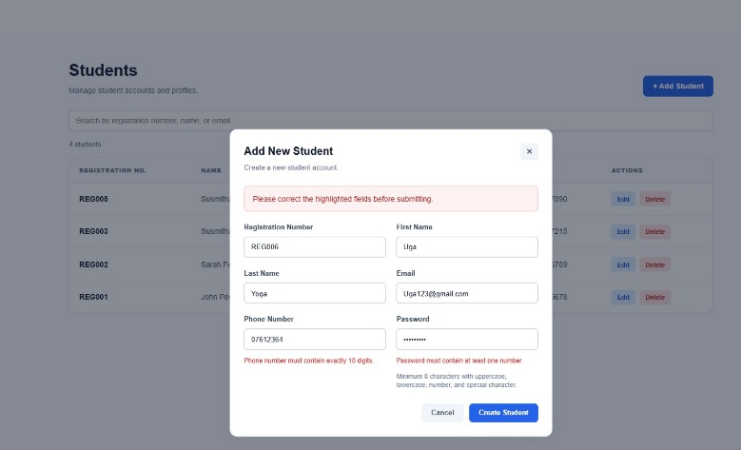
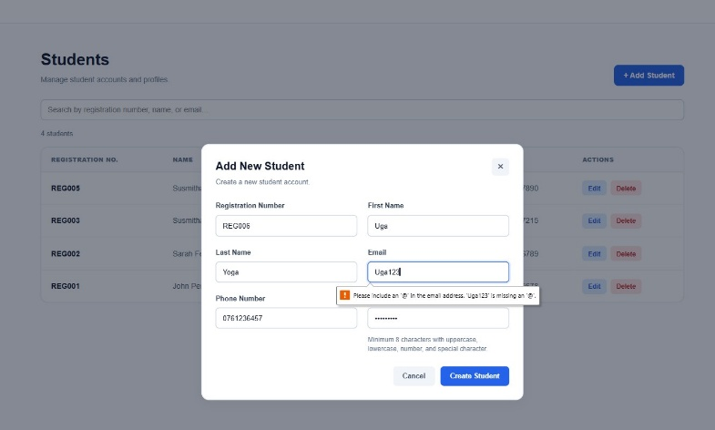

Evidence 02 – Backend Validation / Valid Student Operation
Related: AC-012, AC-013, AC-014, AC-015, AC-016, AC-017
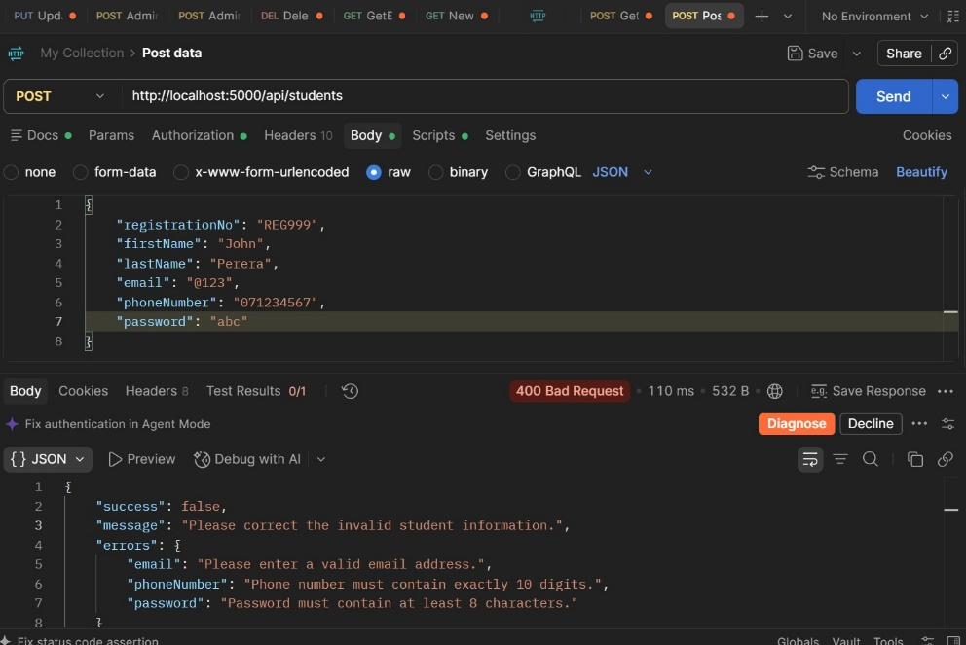
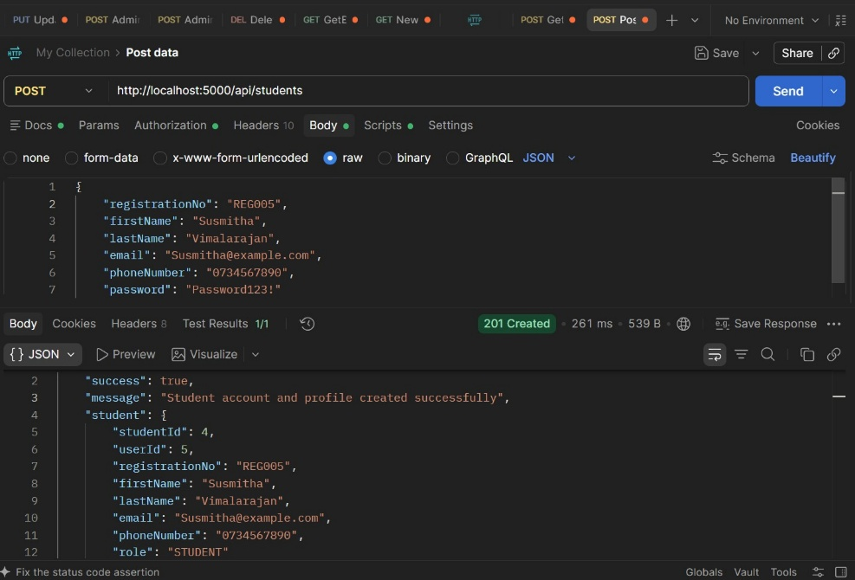

Final Result
Item | Result
Requirements | Met
Implementation | Completed
Testing | Passed
Acceptance Criteria | All Met
Existing CRUD | Verified
Authentication & Authorization | Verified
Password Security | Verified
Final Status | Accepted

Final Summary
CR-004 was implemented as a validation enhancement for the administrator student Add and Edit operations.
The implementation validates registration number, first name, last name, email address, phone number, and password according to the defined requirements. First and last names require a minimum of three characters and valid alphabetic characters. Email addresses must follow a valid email format, while phone numbers must contain exactly 10 numeric digits.
Strong password validation was implemented for new student accounts. Passwords must contain at least 8 characters, including uppercase and lowercase letters, a number, and a special character.
Both client-side and server-side validation were implemented. Client-side validation prevents invalid information from being submitted through the form, while server-side validation prevents validation bypass through direct API requests.
Existing Add, Edit, Delete, administrator authentication, authorization, database operations, API endpoints, and password hashing mechanisms were preserved.
The implemented functionality was tested using frontend validation, backend API testing, positive and negative test cases, and regression testing. All defined acceptance criteria were verified successfully.

Issues / Limitations
No significant issues identified.
The CR-004 requirements were implemented within the defined scope. No database schema redesign, new student management API endpoints, authentication changes, authorization changes, or unrelated module changes were required.

Student Name: Susmitha Vimalarajan
Student ID: JFICT24_30
Date: 08 October 2026
Signature:

